Standalone bushfire plan
2022-2023

Purpose

The Standalone bushfire plan document is a detailed plan of how your school is to prepare and respond to a catastrophic fire danger rating alert or to a bushfire event.

You must complete this template to have a plan in place to respond to a bushfire emergency until, during and after the attendance of Emergency Services. This plan is to be read in conjunction with the Department of Education Principal’s guide to bushfire.

All staff, students, contractors and visitors on the school or facility site are to follow this completed plan in the event of a bushfire emergency. All other emergencies are to be managed in accordance with the school’s incident management plan.

You are required to complete and lodge your plan online by the 31 August, before the bushfire season begins.

- School details

To complete this plan:

- use the Principal’s guide to bushfire (Principal’s guide) to help you
- on the front cover of the document, remove the word ‘template’ and replace it with your school’s name
- enter information into the grey sections of this document, following the prompts in the square brackets where featured. You can add extra rows to tables where necessary.

When your plan is complete, access Prepare for bushfire season at your school on Ikon to lodge it as one document (include appendices).

School name  (include name of co-located school or facilities if applicable) | Lesmurdie Senior High School
School address | 21 Reid Road, Lesmurdie
Education Region | South Metropolitan
DFES Region  Local Fire station  Local Bush Fire Brigade | Metro South East  Kalamunda Volunteer Fire & Rescue Service, Kalamunda  Kalamunda Volunteer Bush Fire Brigade, Walliston
Number of students | 1020
Number of students requiring extra support if evacuating | 0
Number of staff | 174
Number of school sides bordered by bush | 4
Names of major roads bordering school | Reid Road, Pomeroy Road, Albert Road
School’s site-specific alert, for example:  - siren/pause x 3  - continuous handbell  - continuous siren or short whistle blasts | Quick blasts of the siren repeated over a 30 second period or  PA Announcement or  Short Whistle blows

Plan prepared by  (principal’s name) | Kerry Chipchase
Date prepared | 15 August 2022

- Emergency response contact list

Enter the contact details into the table below.

Organisation | Details | Phone number / Website
Local police  (eg name of nearest police station) | Forrestfield | 9359 1033 or 131 444
Local hospital  (eg name of nearest hospital or medical emergency facility) | St John of God Midland Public Hospital  Ambulance – Kalamunda | 9462 4000  9334 1233
DFES regional contact | Armadale Office  Event of an Incident | 6424 1500  admin.southeastmetropolitan@dfes.wa.gov.au  13 33 37
Local fire brigade  (eg name of nearest fire station) | Kalamunda Volunteer Fire & Rescue Service, Kalamunda | 9257 1666
Local bushfire brigade  (eg name of nearest station) | Kalamunda Volunteer Bush Fire Brigade, Walliston | 9257 9999
Bus contractors  (ready for pre-emptive closure or offsite evacuation) | Paul’s Bus Company  Buswest - Denise  Lesmurdie Bus Service – Roy  Transperth  Horizons West | 0417 188 434  0409 834 975  0408 197 258  136 213  9351 8980
Electricity provider - in the case of a power outage  (eg Horizon Power or Western Power) | Perth Energy | 9420 0300
State emergency service (if known) | Kalamunda SES | 9257 1649 (0419 969 006)
Poisons information (where relevant) | WA Poisons Information Centre | 13 11 26
Director of Education – contact name | Ken Perris | 9336 9563 / 0408 918 019

Dial 000 in an EMERGENCY

  - Other important emergency sources

- Emergency WA website - https://www.emergency.wa.gov.au/

- Department of Fire and Emergency Services
Information line – 13 33 37
Twitter - https://twitter.com/dfes_wa

- Local radio
- ABC Emergency WA
- ABC local radio
- 6PR
- Emergency equipment

Identify the location and the type of emergency equipment at your site.

Equipment | Details  (include location/s, date checked and any other comments)
Evacuation kit | Deputy Principal School Improvement and Innovation - Storeroom
First aid kit(s) | Lower School, Senior School, HOPE, Nurses Office
Emergency warning or alert system, eg:  - mobile telephones (charged)  - hand-operated fire alarm (portable siren)  - portable radios  - spare batteries. | - Personal phones used  - Leo Surjan – Deputy Principal  - Fire Wardens  - Admin - MCS
Emergency communications equipment | As above
Registers for:  - students  - staff  - visitors. | - Lower School and Senior School Support staff  - Admin  - Admin
Standalone Bushfire Plan:
- hard copy in the evacuation kit.
- copy saved to an online platform for access offsite.

- Bushfire preparation checklist
Principals must:
- complete this bushfire preparation checklist annually
- provide evidence in the form of notes to show that management activities have been actioned
- inform all staff members of their responsibilities.

Management activities | ☑ or NA | Evidence
The annual review of the Standalone bushfire plan has been completed before the start of bushfire season. |  | 15 August 2022
Consulted and received advice in preparing your Standalone bushfire plan from any of the below (as relevant):  - local Emergency Services  - Department of Fire and Emergency Services  - Department of Biodiversity, Conservation and Attractions – Parks and Wildlife Service  - local volunteer fire brigade  - WA Police Force  - local emergency management committee (LEMC) or local government representative  - community emergency services manager if there is one for the area. |  | Correspondence with Anna Dietrich from DFES on the Bushfire Risk Assessment and Treatment Plan as part of DFES Bushfire Risk Management March 2022  LEMC meeting 24 February 2022, 24 May 2022 and 25 August 2022
Staff have been made aware of the Standalone bushfire plan through:  - staff meetings  - staff bushfire induction session that includes:  - an overview of the Standalone bushfire plan  - how to turn off evaporative air conditioner units, the location of switches  - how to close roof vents  - the types of Bushfire Warnings issued by the Department of Fire and Emergency Services and the Emergency Alert telephone warning system  - to direct bushfire media enquiries to the Department’s media unit (08) 9264 5821. |  | Staff Development Days Terms 1 and 4  Included as part of induction of new staff members
Students and parents or carers have been made aware of the Standalone bushfire plan through:  - key bushfire safety messages incorporated into the curriculum  - newsletters  - school information booklet (include actions and procedures)  - school website |  | Three drills per year during Bushfire season  Bushfire plan promoted on Facebook at the beginning of terms 1 and 4  http://www.lesmurdie.wa.edu.au/about-lshs/policies/
Communication plans are in place:  - ‘emergency response contact list’ completed (refer to section 2)  - ‘bushfire response telephone tree’ completed (refer to section 4)  - communication templates for sample emergency text message, newsletter content and school notice text are complete (refer to Appendix D)  Note: Contact lists for staff and parents must be current. |  | 15 August 2022  15 August 2022  15 August 2022
Emergency equipment available and checked (as listed in section 5):  - evacuation kit checked at least once per term  - emergency warning or alert system works  - emergency communications equipment available  - first aid kit(s) available  - registers for students, staff and visitors readily accessible for roll call |  | Business Support Officer to check  Week 1 of each Term  Register available on line. Hard copies to be printed out on days of extreme fire danger
Evacuation drills practised to your onsite ‘safer building location(s)’:  - before the start of the bushfire season  - at least once per term during the bushfire season.  Note: You must do at least three drills per year. |  | 24 November 2022  22 February 2023  11 May 2023  2 November 2023
Onsite ‘safer building location(s) are identified. Do not use an open area such as a school oval or non-enclosed building.  - shown in your school site plan in section 7.1  - listed in the Incident Management Plan  - regularly checked for readiness  - local emergency services are informed of location(s)  Note: For further information, refer to section 4.2 in Principal’s guide. |  | Our safer building locations are  C Block  D Block  E Block  F Block (Home Ec only)  J Block  Performing Arts Centre  Library and  Administration
Two or more suitable offsite evacuation locations have been identified in case one of the offsite locations is under threat from the bushfire. In most cases the off-site evacuation location will be determined by the incident controller.  Local government authority has provided written or email approval on the use of these offsite locations.  Note: For further information, refer section 4.3 in the Principal’s guide. |  | Due to logistics involved in evacuating, DFES and City of Kalamunda to advise. Hartfield Park and Kalamunda Senior High School have been identified as offsite locations for evacuation
The asset protection zone, which is a minimum distance of 20 metres surrounding the school is checked and:  - clear of all rubbish, long dry grass, bark, flammable and combustible materials, including leaf litter and unused piles of mulch  - maintained routinely throughout the year  Note: For further information, refer to section 4.3 in the Principal’s guide. |  | Mitigation process with Trevor Dunstan OBRM commenced Term 2 2022.  Ongoing clearing of fuel load by LSHS Manager of Facilities and Grounds – Jeff Lever
Check the fuel load management (the clearing of dry grass, leaves, twigs, dead vegetation and dead bark) within the hazard separation zone (extending 80 metres from the outer edge of the asset protection zone) has reduced and:  - the likelihood of crown fires developing close to buildings  - spot fire ignition potential within the zone |  | This is the responsibility of Dept of Parks and Wildlife. Scheduled burn off was undertaken in April 2022.
The use of machinery (such as angle grinders, mowers or machines with internal combustion engines) is restricted on severe fire danger days.  The use of any machinery or power tools that can generate sparks on total fire ban days is not permitted.  Note:  - Any ‘hot works’ including welding and grinding or the operation of plant, equipment or machinery in bushland areas, can potentially ignite vegetation and cause bushfires.  - Refer to the Principal’s guide to bushfire – ‘Terminology’ (section 13 of the guide) |  | All contractors aware of restrictions on machinery use on high fire danger days  Staff monitor alerts through ABC radio

- Bushfire action plan maps

  - Onsite ‘safer building location(s)’ Do not use an open area such as a school oval or non-enclosed building.

Insert your school map and include:
- The onsite safer building location(s) and routes to access this building
- location of fire hydrants (insert ‘hydrant’ icon on map)
- electrical switchboards (insert text boxes containing ‘switchboard’ on map)
- phones and communication board (insert icon and text box on map)
- first aid kits (insert ‘first aid’ icon on map)
- evacuation kits (insert text box onto map to show ‘evacuation kit’ location).

A sample of an action plan map is available in section 9.2 of the Principal’s guide.

Our bushfire plan requires us to remain in classrooms, except for students in D&T, Phys Ed, transportables and the Music Rooms who should move to:  - J57 into J Block open area  - T37, T38, T39, T40 and T49 and Music into E Block East (Upper Common Room)  - F45, F46, F47, F48 and F51 into E Block West (Yr 12 Common Room)  - Phys Ed classes on the oval and in the gym into the PAC  - Visitors and Canteen Staff to relocate to front office of Admin building  - All other Support Staff to stay in Lockdown within their areas. | Emergency Dial 000  Primary action:  Determine if the bushfire is a threat to the school. Monitor official sources listed in section 2.  Secondary action:  Refer to Appendix B for the procedures to Relocate to onsite ‘safer building location(s).
C Block
D Block
E Block
F Block (Home Ec only)
J Block
Performing Arts Centre
Library and
Administration
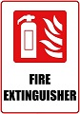  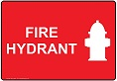 | Map last updated:  07/02/20
  - Offsite evacuation locations
Insert the school site map and include:
- assembly point(s) (insert ‘assembly point’ icon on map)
- identify two offsite evacuation locations
- include directional arrows to show routes to your offsite evacuation locations.

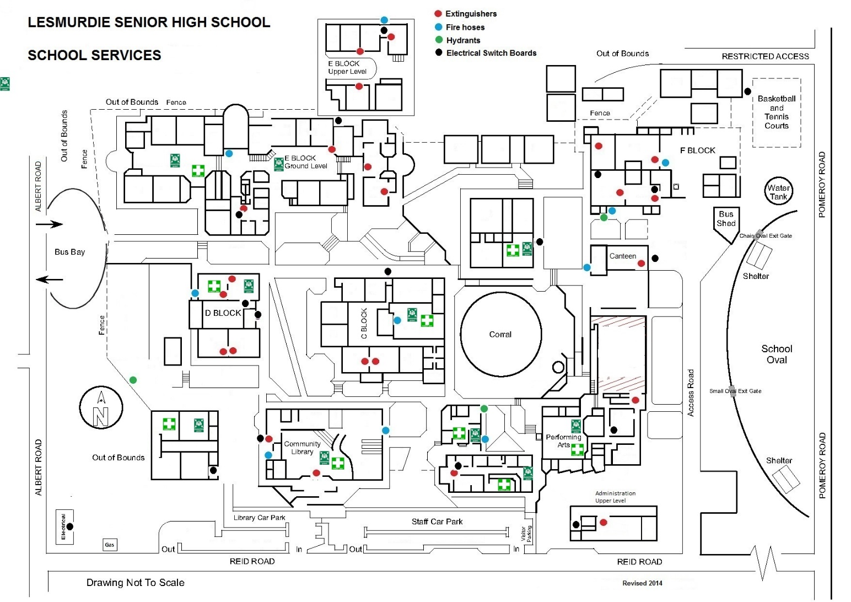 | Emergency Dial 000  Primary action:  Determine if the bushfire is a threat to the school. Monitor official sources listed in section 2.  Secondary action:  Refer to Appendix B for the procedures to Relocate to offsite evacuation location
 | Our bushfire plan requires us to remain in classrooms, except for students in D&T, Phys Ed, transportables and the Music Rooms. Evacuation will be under the instruction of the Emergency Services.
Map last updated:
27/08/20

- Bushfire mitigation management register

Attach your bushfire mitigation register for any treatment works or actions undertaken to reduce risk (refer section 3.2 of the Principal’s guide)

Note:
If your school has not received a bushfire risk assessment and treatment plan and had the identified works undertaken, you are not required to complete this register.

Reference number | Bushfire mitigation actions | Target date for completion | Responsible | Source of funds | Notes | Completion date
DFES map item reference | Treatment strategy / works required | Date  (dd/mm/yyyy) | The staff member name who will sign off the action as complete | eg school or central funding | Progress or issues associated with the work (including date of progress or issues) | Date  (dd/mm/yyyy)
Figure 1 Map of school site | Burn off | April 2022 | Leo Surjan | Park and Wildlife | N/A | April 2022

- Advice from Department of Fire and Emergency Services and other agencies

Record in the table below any bushfire advice received by the school from:
- Department of Fire and Emergency Services, including the local DFES regional office
- local fire brigades and community emergency services manager
- local government
- local government local emergency management committee
- external experts.

Identify the date and source of the advice.

Date of advice | Agency  name | Advice received | Name of officer (who provided advice) | Contact number or email address
Term 2 2022 | DFES (OBRM) | Parks and Wildlife burn-off would commence between April and Nov 2022 | Trevor Dunston | 0408 757 564

Appendix A – Bushfire warnings stages

Issued by the Department of Fire and Emergency Services and Department of Biodiversity, Conservation and Attractions – Parks and Wildlife Service.

Emergency services communicate information in a number ways during a bushfire event. Use these warnings to understand when your need to activate your bushfire procedures (refer to Appendix B).

Bushfire warning stages
1 |  | A fire has started but there is no known danger.  This is general information to keep principals informed and up to date with developments.  Principals must:  - turn off evaporative air conditioners and ensure roof vents are closed.  - check and patrol school regularly for bushfire activity, paying special attention to the evaporative air conditioners.
2 |  | There is a possible threat to lives and property. Conditions are changing.  Principals must prepare to:  - evacuate  - or  - move students, staff and visitors to their pre-determined onsite ‘safer building location’. They must not be moved to an open area.  Evacuation orders are:  - issued by the incident controller or emergency services if required.  - relayed via a variety of official sources such as the DFES website and Emergency WA website.  It is vital that the principal:  - accesses bushfire information from official sources.  - makes an informed decision to stay on-site or evacuate offsite based on advice from the incident controller or emergency services.
3 |  | A school is in danger as its area will be impacted by fire. Take immediate action to survive.  Principal will be advised whether staff, students and visitors can leave the area or if they must shelter where they are as the fire burns through the area.  An emergency warning may be accompanied by a siren sound called the Standard Emergency Warning Signal (SEWS).  Cont…  Evacuation orders are:  - directed by the incident controller or emergency services  - relayed via a variety of official sources, such as the Bushfire warning system, DFES website and Emergency WA website.  It is vital that the principal:  - accesses bushfire information from official sources  - makes an informed decision to stay onsite or evacuate offsite based on the advice.
4 |  | The danger has passed and the fire is under control, but stay alert in case the situation changes.  It may not be safe to return to school yet.

Appendix B – Procedures in event of a sudden bushfire

Relocate to onsite ‘safer building location(s)’

You may be instructed to relocate to your onsite ‘safer building location(s)’. Do not use an open area such as a school oval or non-enclosed building

Initiate the below procedure if the following occurs:

- a ‘Watch and Act’ or ‘Emergency Warning’ alert is issued on the Emergency WA website or the Department of Fire and Emergency Services Bushfire Warnings page of the Department of Fire and Emergency Services website (refer to Appendix A for details about the alerts); and
- instruction from the Department of Fire and Emergency Services, Emergency Services or your Director of Education.

Follow these procedures to relocate to the onsite safer building location(s).

Action | Notes (if required)
Dial 000 for emergency services and follow advice.
Remain in contact with the Department of Fire and Emergency Services and monitor official bushfire information sources shown in section 2.1.

Activate your incident management team to carry out their responsibilities (refer to section 3).

Use your emergency response contact list to contact stakeholders (refer to section 2).

Follow your bushfire response telephone call tree to communicate with the school community.

Ensure parents receive emergency text message alerts to:
- inform them of relocation
- keep them updated (use the emergency text message alert templates).

Note: Parents must not collect students until instructed.
Confirm:
- evaporative air conditioners are turned off
- all building roof vents, windows and doors are closed before anyone enters the onsite safer building location(s).

Take emergency equipment (refer to section 5):
- registers for students, staff and visitors
- evacuation kit
- mobile phones (charged).

Sound school emergency warning or alert system.

Follow advice from the incident controller or emergency services, the Manager, Security and Emergency Management or the Director of Education to move to the onsite safer building location(s) (refer to section 7.1 for map)

Note: Students and staff must remain in classrooms unless they are directed to move to an onsite safer building location.

Check student, staff and visitor registers after moving to an onsite safer building location (roll call). Advise the police if anyone is missing.

Note: You must give special consideration to students with known respiratory conditions.

Update the emergency services on the location of students, staff and visitors.

Wait for the emergency services to arrive or the incident controller to provide you with further information.

Ongoing advice will also be provided by the Manager, Security and Emergency Management or the Director of Education.

Continue to monitor official bushfire information sources shown in section 2.1.

The Department will consult the incident controller or emergency services and notify you when it is safe to return to classrooms or for students to be collected by parents. You will receive advice from the Director of Education.

Offsite evacuation procedures

You may be instructed to relocate to your offsite evacuation.

Initiate the below procedure if the following occurs:

- ‘Watch and act’ or ‘emergency warning’ bushfire warning alert on the Emergency WA website or the Department of Fire and Emergency Services Bushfire Warning system is invoked (refer to the bushfire warnings listed in Appendix A); and
- Direction from Department of Fire and Emergency Services, incident controller or Emergency services to evacuate offsite; or
- Direction from the Deputy Director General Schools or the Manager, Security and Emergency Management. The Director of Education will relay the decision to you to evacuate offsite.

Follow these procedures if you need to evacuate to an offsite evacuation location during a bushfire event.

Action | Notes (if required)
Dial 000 for emergency services and follow advice. Remain in contact with Department of Fire and Emergency Services and your Director of Education. Monitor official bushfire information sources shown in section 2.1.

Activate your incident management team to carry out their responsibilities (refer to section 3).

Refer to the ‘emergency response contact list’ to contact stakeholders (refer to section 2).

Follow advice from the emergency services or the Manager, Security and Emergency Management or the Director of Education to decide which of the school’s offsite evacuation location(s) is the safest to use (refer to section 7.2).

Identify an assembly area where staff, students and visitors can gather to prepare for offsite evacuation.

Note: Students and staff must remain in classrooms unless they are directed to move to an onsite safer building location and/or onsite assembly area.

Follow the ‘bushfire response telephone call tree’ to communicate with the school community.

Ensure parents receive emergency SMS alerts to:
- inform them of relocation
- keep them updated (refer to emergency text message alert templates in Appendix C).

Note: parents must not collect students until instructed.

Confirm:
- evaporative air conditioners are turned off
- building roof vents and doors are closed.

Take emergency equipment (refer to section 5):
- registers for students, staff and visitors
- evacuation kit
- mobile phones (charged).
Sound school emergency warning or alert system.

Move all students, staff and visitors from the assembly area to evacuate offsite.

Check registers after evacuating staff, students and visitors (roll call). Advise the police if anyone is missing.

Update the emergency services incident controller on location of students, staff and visitors.

Wait for emergency services to arrive or the incident controller to provide further information. The Manager, Security and Emergency Management or the Director of Education will provide ongoing advice. Continue to monitor official bushfire information sources shown in section 2.1.

The Department will consult the incident controller or emergency services and notify you when it is safe to return to classrooms or for students to be collected by parents. You will receive advice from the Director of Education.

